Question 1

Interface Layout Design
Using Figma, create a simple wireframe layout for any software system of your choice (for example: Online Store, Student Portal, or Library System).
Your interface should include the following components:
- Header section
- Navigation menu
- Main content area
- Footer section
Use shapes and text to represent these components and attach a screenshot of your design in the lab report.
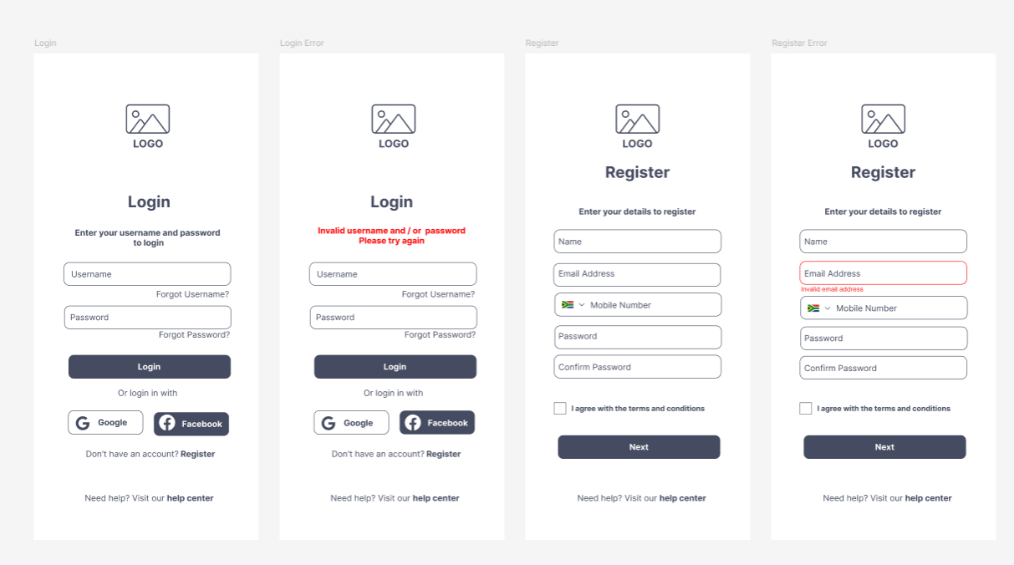

Question 2

Login Page Interface Design
Using Figma, design a Login Page interface for the same system created in Question 1.
Arrange these components properly to create a simple and clear login interface. Attach the screenshot of the design in the lab report.
